How to build a deployable
Microsoft Access 2003 Runtime with integrated Service Pack 3

There is a big issue when deploying an Access 2003 runtime along with a database: It is only available in its unpatched original version that you can build with the Microsoft Access 2003 Developer Extensions. Any later service packs for Office 2003 have to be applied separately to it if you want your costomer to get the most recent version of Access 2003.
While the original runtime setup files are only 30 MB in size you have to accompany them with the Office Service Pack 3 (120 MB) and an also required hotfix file (4 MB). Furthermore you have to instruct your customer or his administrator how to install all that or alternatively make an associated install script which executes the sequence.

The problem traces back in the fact that until now there was no known possibility to create an administrative installation point for the runtime package, which is an requirement to apply installer patches. It does not support the /a switch of Windows installer.

Thanks to a discussion thread at www.appdeploy.com there is now a chance to change the situation. You can find the original discussion here:
http://www.appdeploy.com:80/messageboards/tm.asp?m=30192&mpage=1&key
A big thank you to the moderator Nick (nheim) of that forum!

Below I try to explain step by step how to create a custom Access 2003 Runtime setup including all recent service packs.

Workbench

First create a set of new empty directories like this:

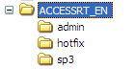

Requirements

First you need the original runtime files. You can extract them from the Office 2003-CD using the Setup and deployment wizard included in the Access 2003 Developer Extensions. That’s the only way to get them according to Microsofts license agreements. Put accessrt.cab and accessrt.msi in the root folder you created above (ACCESSRT_EN):

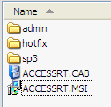

Next you need the complete Office 2003 Service Pack 3 (SP3). Download it from
https://www.microsoft.com/downloads/details.aspx?FamilyID=E25B7049-3E13-433B-B9D2-5E3C1132F206&displaylang=en
and store it in the sp3 folder.
Then extract the contents of the service pack file. It’s just a cab file and you should be able to uncompress it using a tool like WinZip or WinRAR. These tools have explorer context menu extensions like
„Extract here…“. After extraction our sp3 folder looks like this:

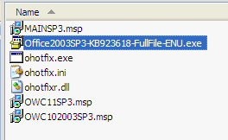

You can now delete the marked original sp3 package file – we don’t need it any longer.

Then download the Access 2003 SP3 Hotfix. You will find it in a knowledgebase article called
Description of the Access 2003 post-Service Pack 3 hotfix package: December 18, 2007 at
http://support.microsoft.com/kb/945674/en-us
Navigate to „Download the hotfix package now“ there or alternatively load it directly using this url:
http://download.microsoft.com/download/6/4/0/640eb828-5556-4588-8e1a-66fe8e0e3ad9/office2003-kb945674-glb.exe
Store it in our hotfix folder and extract the one and only file in it like done above with the SP3 file:

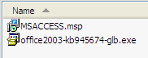
Again delete the exe file after extraction.

Now it comes to a more diffcult part: We need a tool to edit the MSI files and some scripts to rebuild a new accessrt.msi. You get all this for free with the Vista Windows SDK at
http://www.microsoft.com/downloads/details.aspx?FamilyID=4377F86D-C913-4B5C-B87E-EF72E5B4E065&displaylang=en
It’s your decision what kind of download to use there:

If you choose the complete ISO download you will need more than 1 GB to store it. This would be the recommended method if you want to use it for more than just patching the runtime. It contains information, developer tools and samples for nearly everything that deals with Windows and its API.

If you choose the Web Install then you can tell the installer which parts of the SDK to download. In this case activate at least the following options in the custom install method:
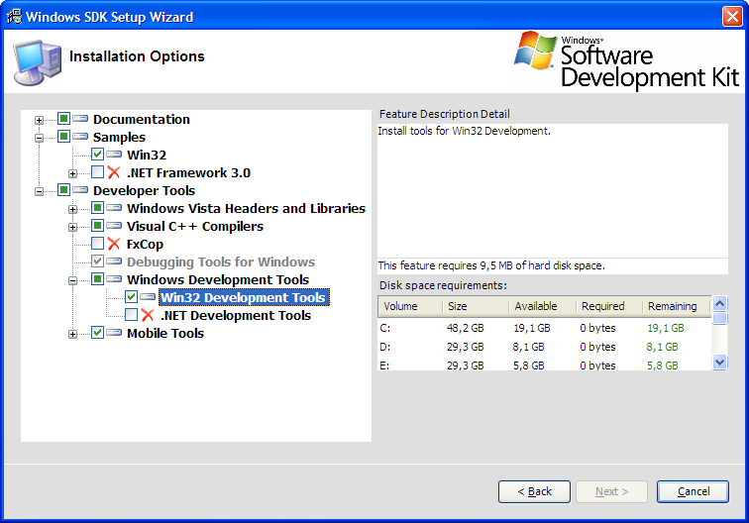

Activate
Samples\Win32
and
Developer Tools\Windows Development Tools\Win32 Development Tools.

After having installed the SDK there is another required step to get the tool we need: Orca.
Navigate to ..\VistaSDK_Root\Bin and doubleclick orca.msi.
You will find some information about Orca at http://msdn.microsoft.com/en-us/library/aa370557.aspx
Orca setup configures a new explorer context menu extension. When rightclicking a msi package there is now offered a new entry Edit with Orca.

Two auxiliary script files we need:

Go to ..\VistaSDK_Root\Bin\msitools\Schemas\MSI
and copy the file sequence.msi to our workbench folder ACCESSRT_EN.
Do the same for file WiMakCab.vbs found under
..\VistaSDK_Root\Samples\SysMgmt\MSI\scripts
…but copy it to our admin subfolder.
Action

Patch accessrt.msi to support an administrative installation
- Rightclick sequence.msi in the workbench folder and choose Edit with Orca
- Orca opens. Export the AdminExecuteSequence table:

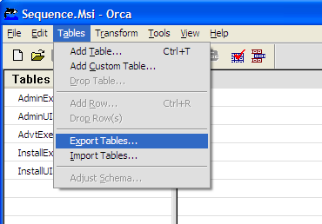
Then…
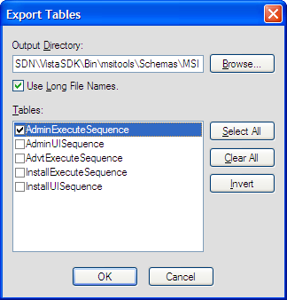

- Choose the workbench folder ACCESSRT_EN as the output directory.
- Close Orca. It created a file AdminExecuteSequence.idt
- Import this file into accessrt.msi. To do that rightclick accessrt.msi and choose Edit with Orca:
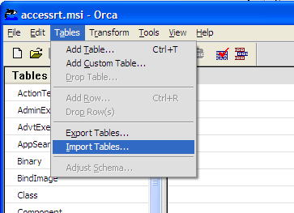

- Import AdminExecuteSequence.idt and save the MSI (Toolbar > Disk symbol)
- Accessrt.msi is now prepared to run an administrative install.

Create the administrative installation point
- Open a command window
- Navigate to the workbench folder, e.g. c:\ACCESSRT_EN
- Execute the following command line:
msiexec /a ACCESSRT.MSI TARGETDIR=C:\ACCESSRT_EN\admin
- …This extracts the contents of the accessrt.cab to the admin subfolder where we now have the patchable administrative installation point

Apply Service Pack 3 to the administrative install
- Open a command window or use the one already open
- Navigate to the admin subfolder, e.g. c:\ACCESSRT_EN\admin
- Apply the installer patch MAINSP3.msp executing the following command line:
msiexec /a accessrt.msi /p c:\ACCESSRT_EN\sp3\MAINSP3.msp TARGETDIR=C:\ACCESSRT_EN\admin
- The complete admin\files subfolder has now been updated with the service pack files. To verify this look under program files\microsoft office\office11 and check the file date and version of msaccess.exe

Apply the Access SP3 Hotfix to the administrative install
- Open a command window or use the one already open
- Navigate to the admin subfolder, e.g. c:\ACCESSRT_EN\admin
- Apply the hotfix patch msaccess.msp executing the following command line:
msiexec /a accessrt.msi /p c:\ACCESSRT_EN\hotfix\msaccess.msp TARGETDIR=C:\ACCESSRT_EN\admin
- The complete admin\files subfolder has now been updated with the hotfix files. Once again verify this checking the file date and version of msaccess.exe

Important: There is no message or anything else that would show you the progress or confirm termination of the above procedures. Windows Installer works asynchronous and the command line returns immediately. Just wait a minute or watch your hard disk led… ;-)

Recreate a CAB file from the installation point
- Open a command window or use the one already open
- Navigate to the admin subfolder, e.g. c:\ACCESSRT_EN\admin
- Start the VBScript WiMakCab.vbs to pack the files using the following command line:
WiMakCab.vbs ACCESSRT.MSI ACCESSRT /L /C
- Wait patiently for completion of the process. It will take at least 1 minute! Just observe the admin subfolder; the process is finished when a new file accessrt.cab has been created.
- Delete the other information files the VBScript generated

We now already have the patched Access runtime but the MSI still considers itself as an administrative install. You can change that using Orca again: >
Some final changes in MSI properties
- Rightclick accessrt.msi and choose Edit witth Orca
- In Orca goto menu View > Summary Information… (see picture below)
- Remove the flag Administrative Image
- Set Compressed by Default to true
- Recommendation: Change the Subject of this version. Rename it to something like
Microsoft Office Access 2003 Runtime SP3+H
This helps you later to identify that it’s a patched version. The subject will be shown in the explorer file properties of the msi (but not in Windows | Software!)
- Close Orca after having saved the changes you made

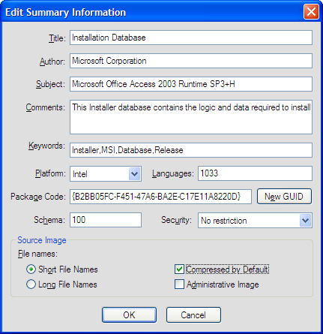

MSI Bug in localized versions of the patched runtime
2008-07-10: A german runtime setup file failed and rolled back showing error no. 2920 fm20enu.dll “Internal error”. We validated the MSI in Orca (Tools > Validate… > ICE35 or complete suite) and found, that file fm20enu.dll_1033 had a sequence number of 4550. This conflicts with the entry for LastSequence in Media > DiskId =1 where the max. CAB file id was 349. Incrementing this value to 4600 solved the issue.
Hint: After creation of the final accessrt.msi lookup the File table in ORCA and sort it descending for column sequence. Set a value larger than the maximum sequence number here for Media > DiskId=1 > LastSequence.

Your patched Access Runtime 2003 is now ready to be deployed.
It is in the two files accessrt.msi and accessrt.cab.

Don’t bother to remove the workbench directories and files in it! There are probably consecutive patches or hotfixes from Microsoft that then can be comfortably applied to the existing administrative installation point in the same manner as described above.

ToDo: It is not absolutely clear how Windows Update handles the new runtime installation. Some tests indicated that Microsoft Update recognizes it as a valid Office 2003 product and applied security patches for some components and Windows Update did not. But don’t rely on this.
Feedback about your experience is welcome.

Sascha Trowitzsch development@moss-soft.de

